Q1 a)

**Spreadsheet Implementation:**

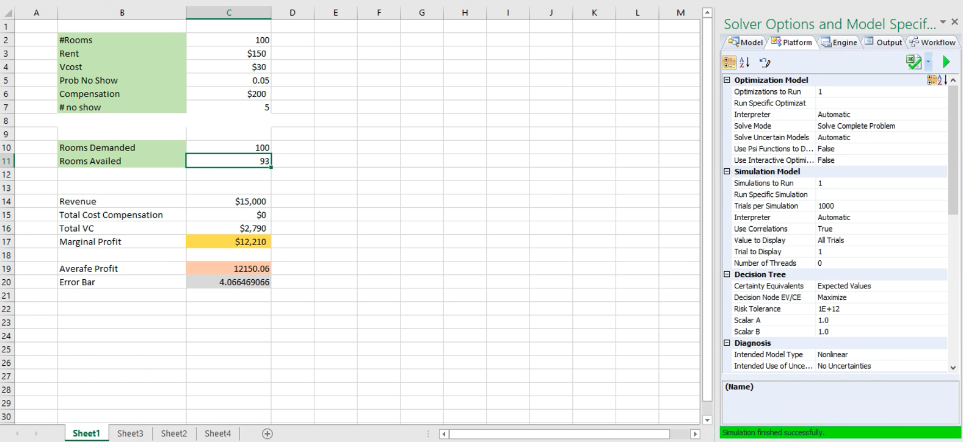

Q1 b)

**The Hotel should accept 105 reservations if it wants to maximize average daily profit as compared to other simulations using 100,110,115 reservations**

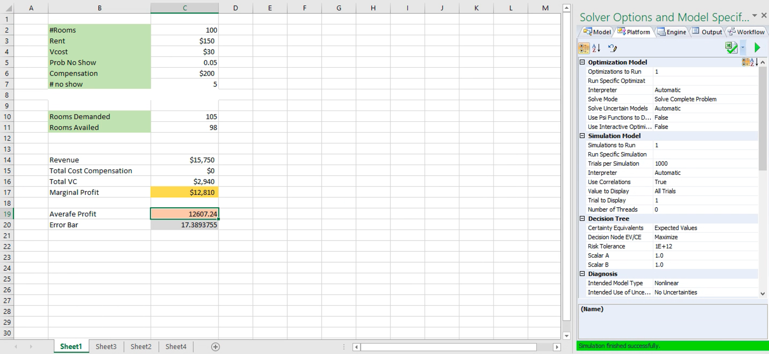

Plot Distribution :

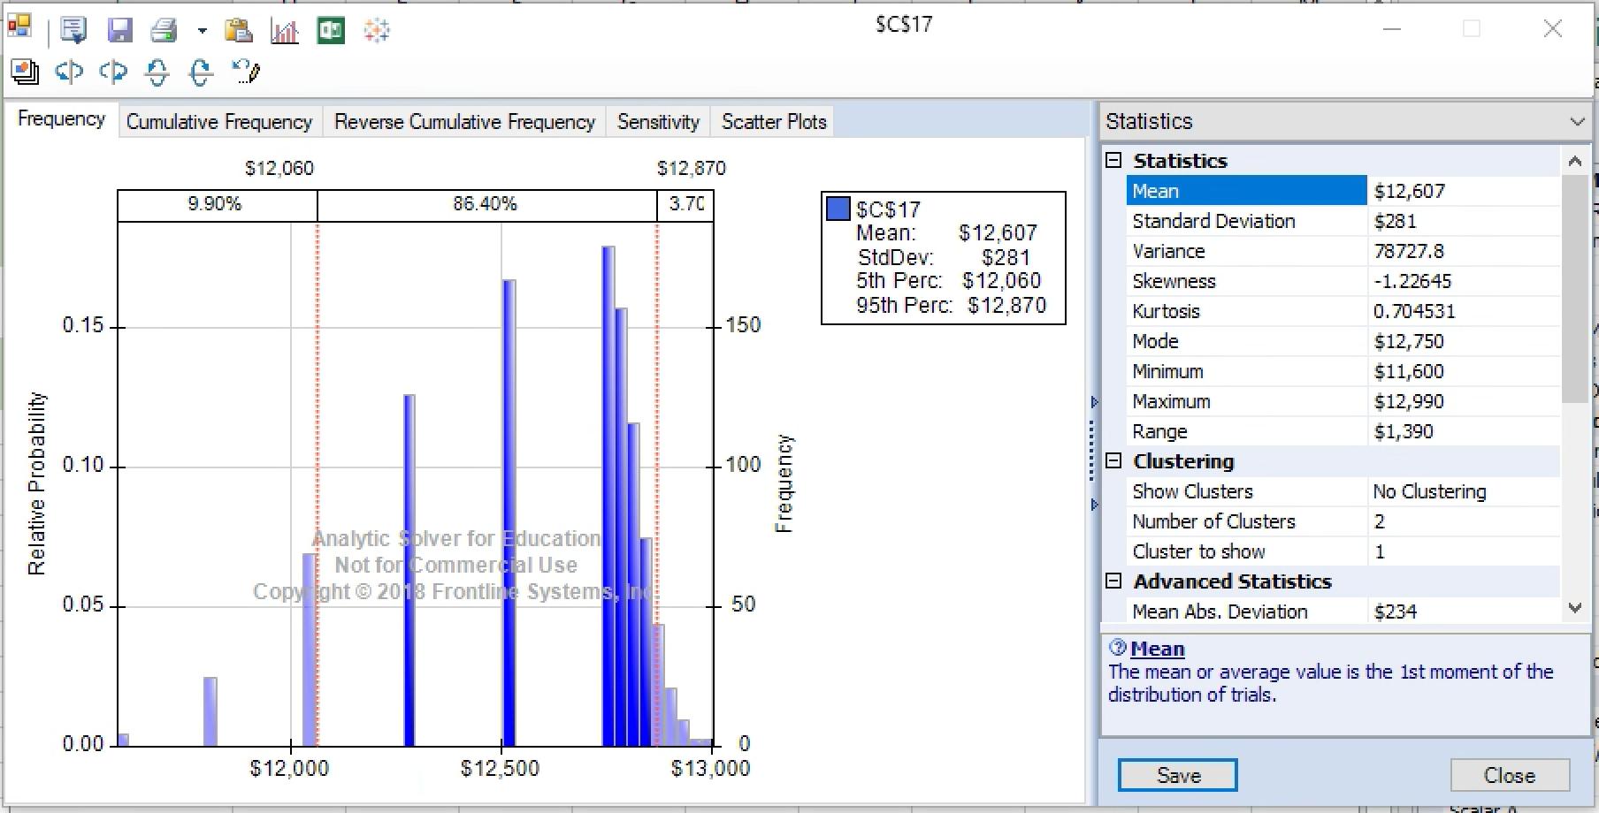

Here are the other simulation screenshots to check maximum profit calculation :

Rooms Demanded: 100

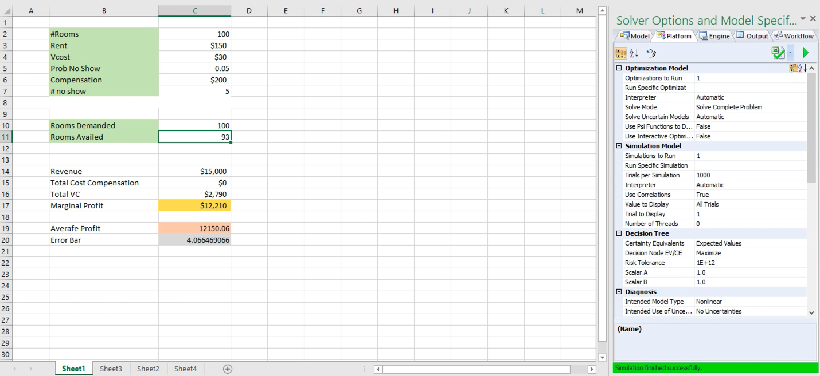

Plot Distribution:

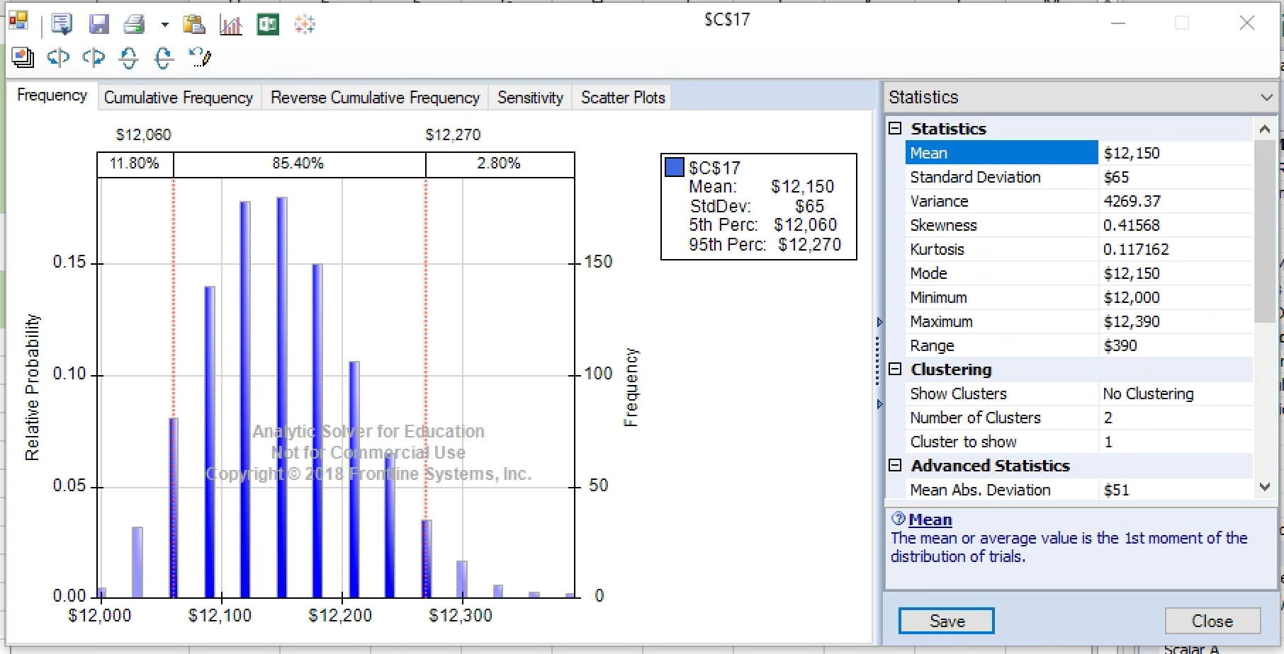

Room Demanded: 110

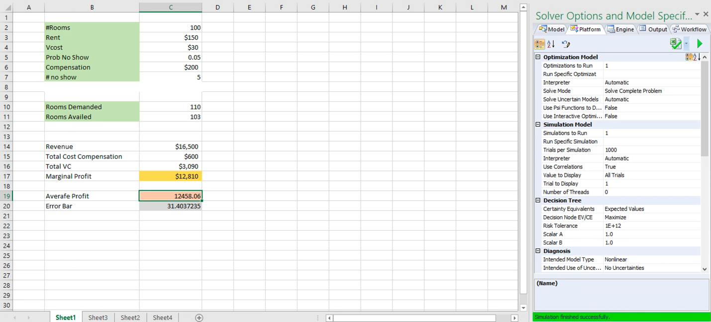

**Plot Distribution:**

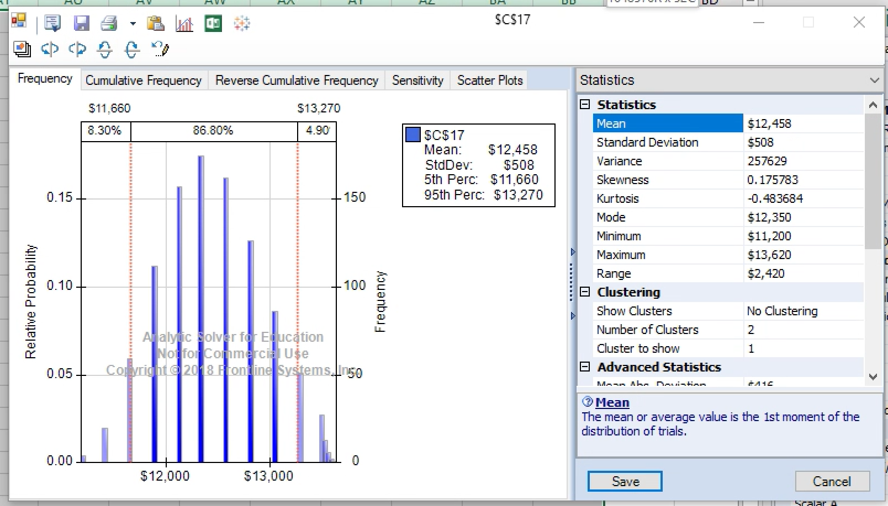

**Rooms Demanded: 115**

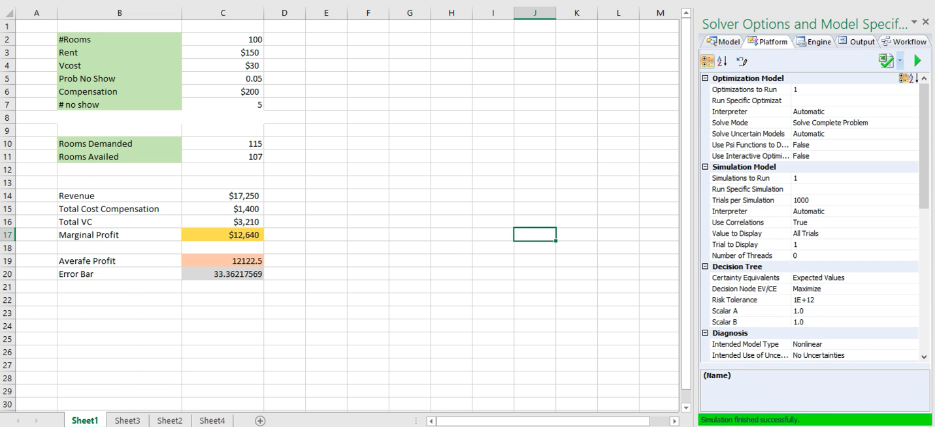

**Plot Distribution:**

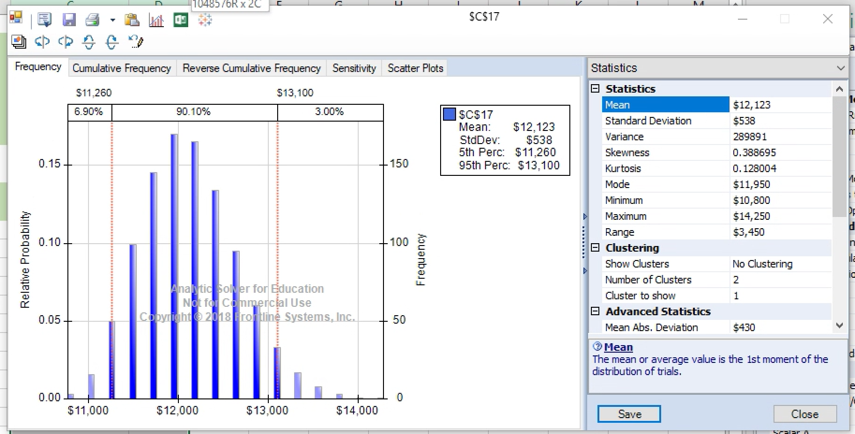

Q1 c)

The average daily profit from part b that is, 105 reservations is $12607.24

Formula Sheet:

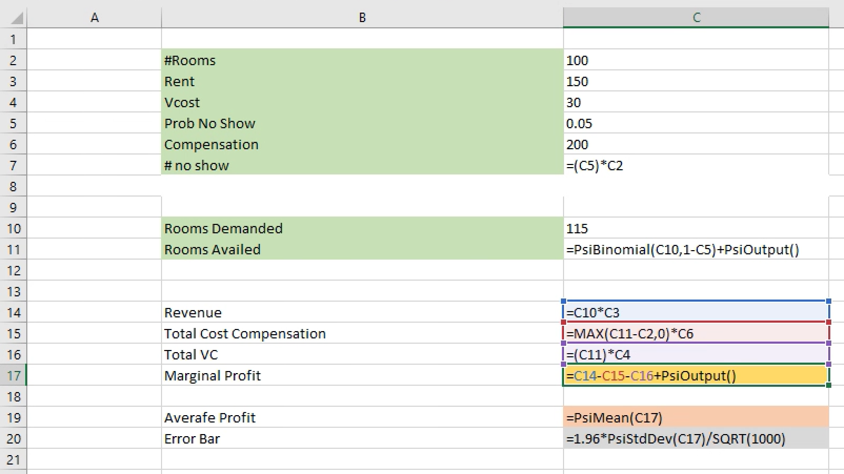

Q2 a)

Probability of all five operations to be completed is **0.035**

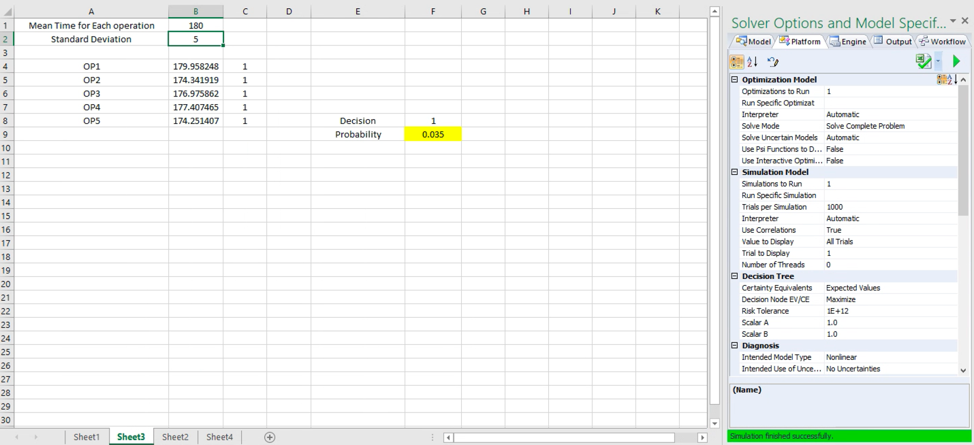

**Plot Distribution :**

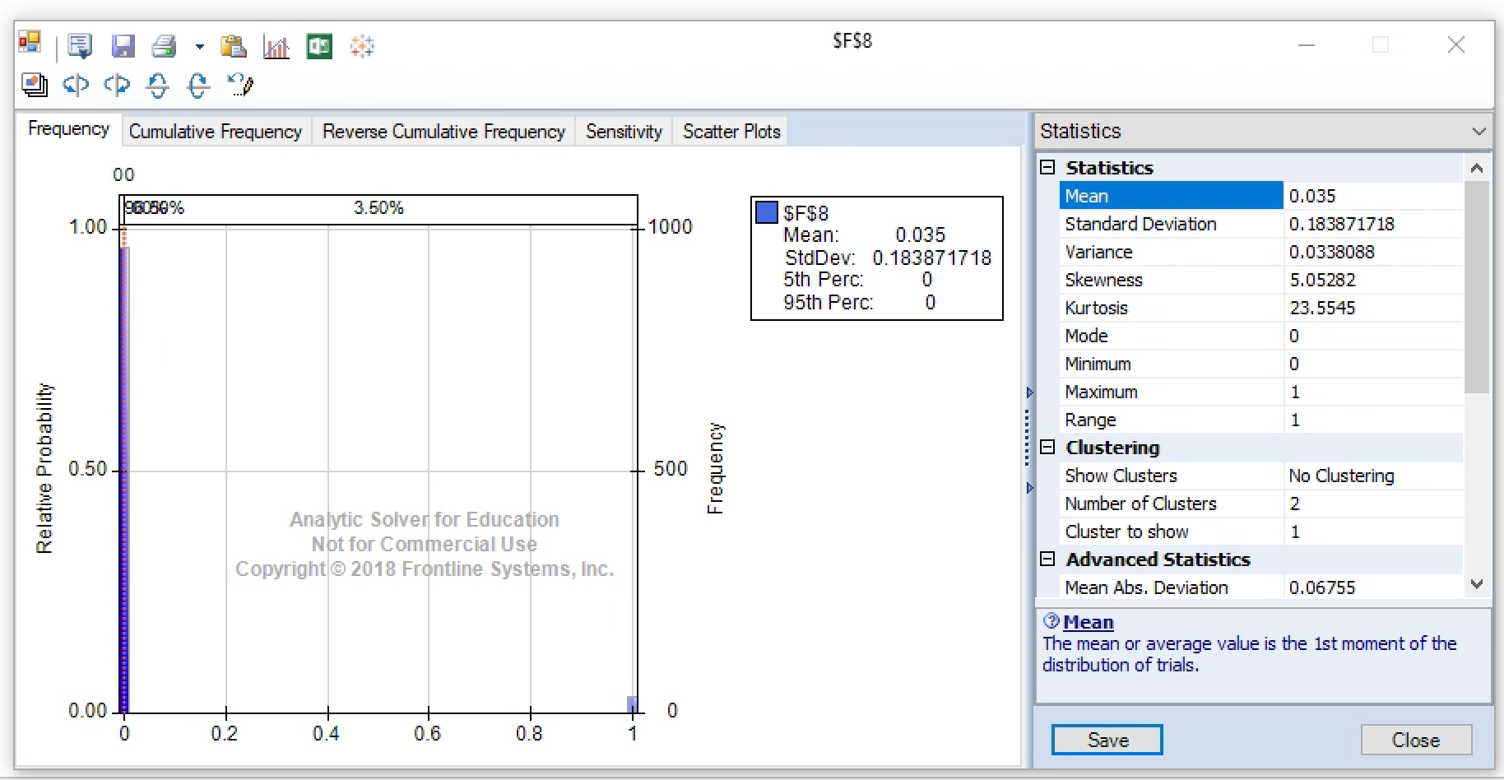

Q2 B)

The cycle time which will ensure that all five operations will get completed in 98% of the time is **194 seconds**

Trial Simulation for converging towards 98% probability:

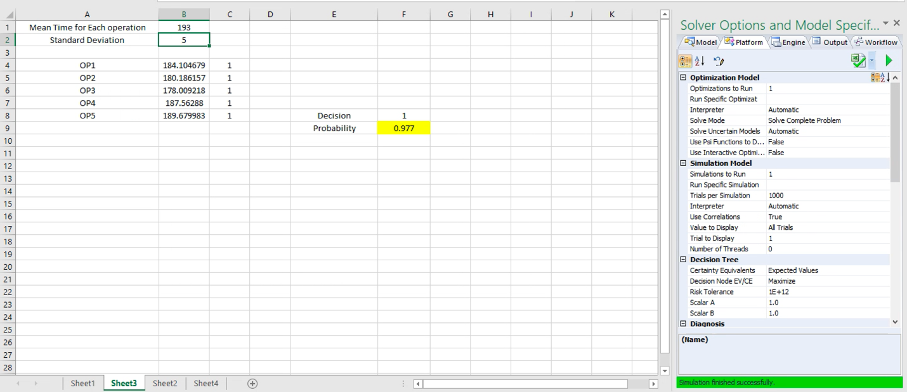

**Plot Distribution:**

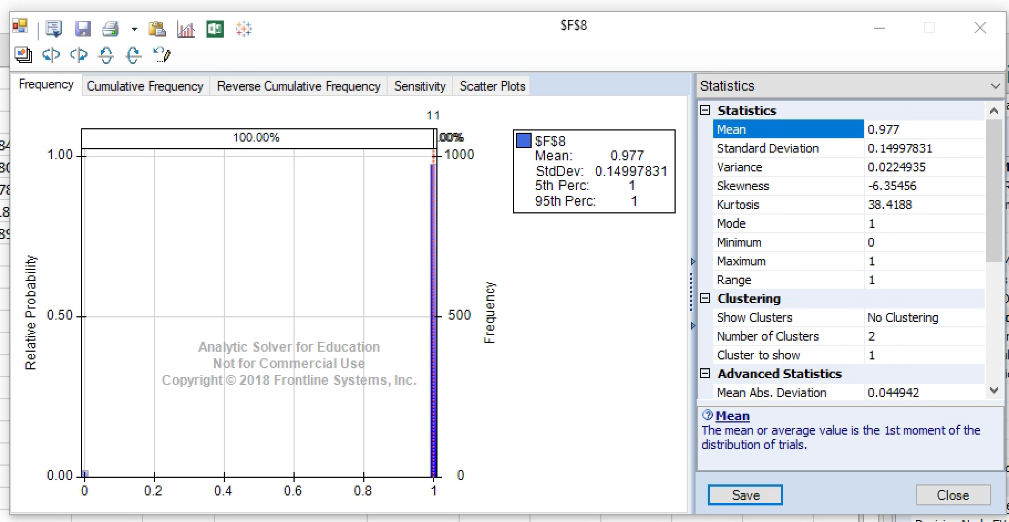

**Simulation for cycle time 194 seconds, which converged to 98% probability and ensured all operation completion completed with this probability**

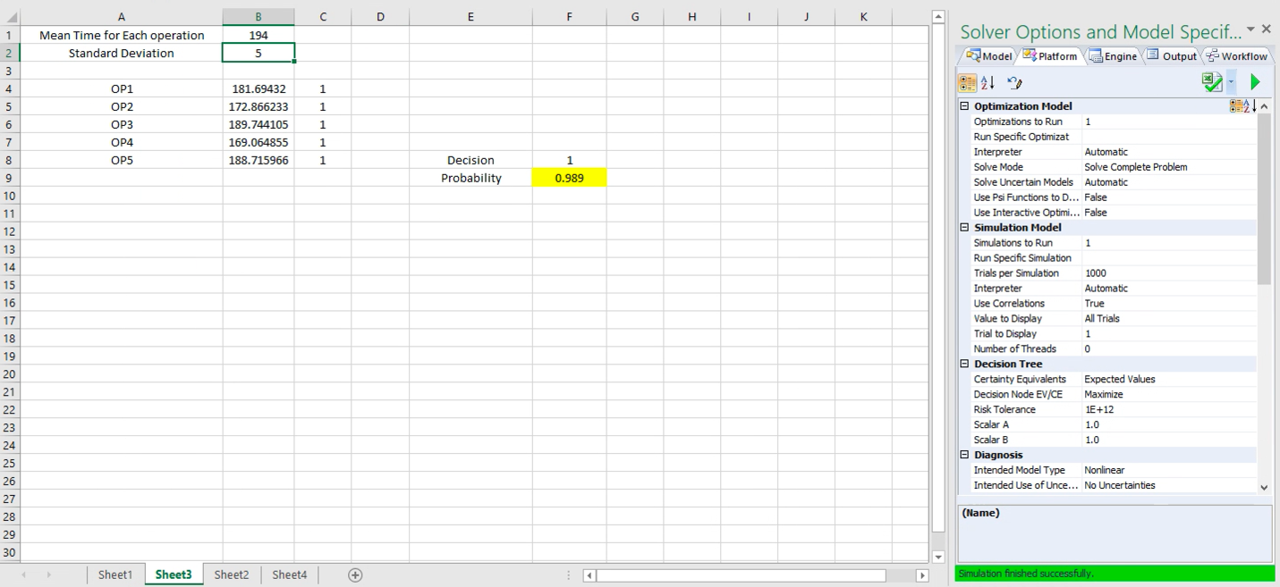

**Plot Distribution:**

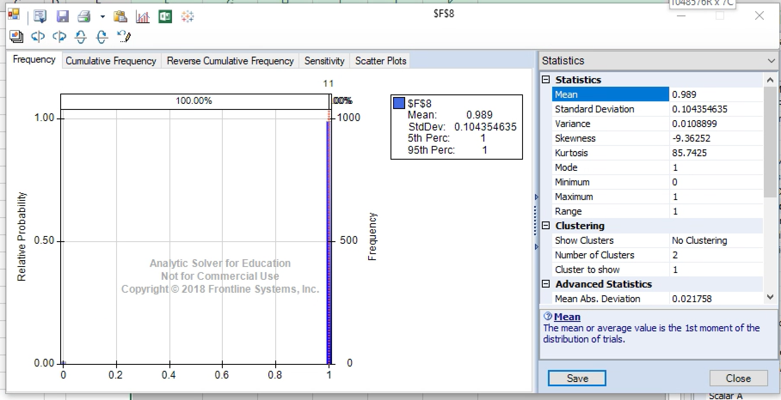

**Formula Sheet:**

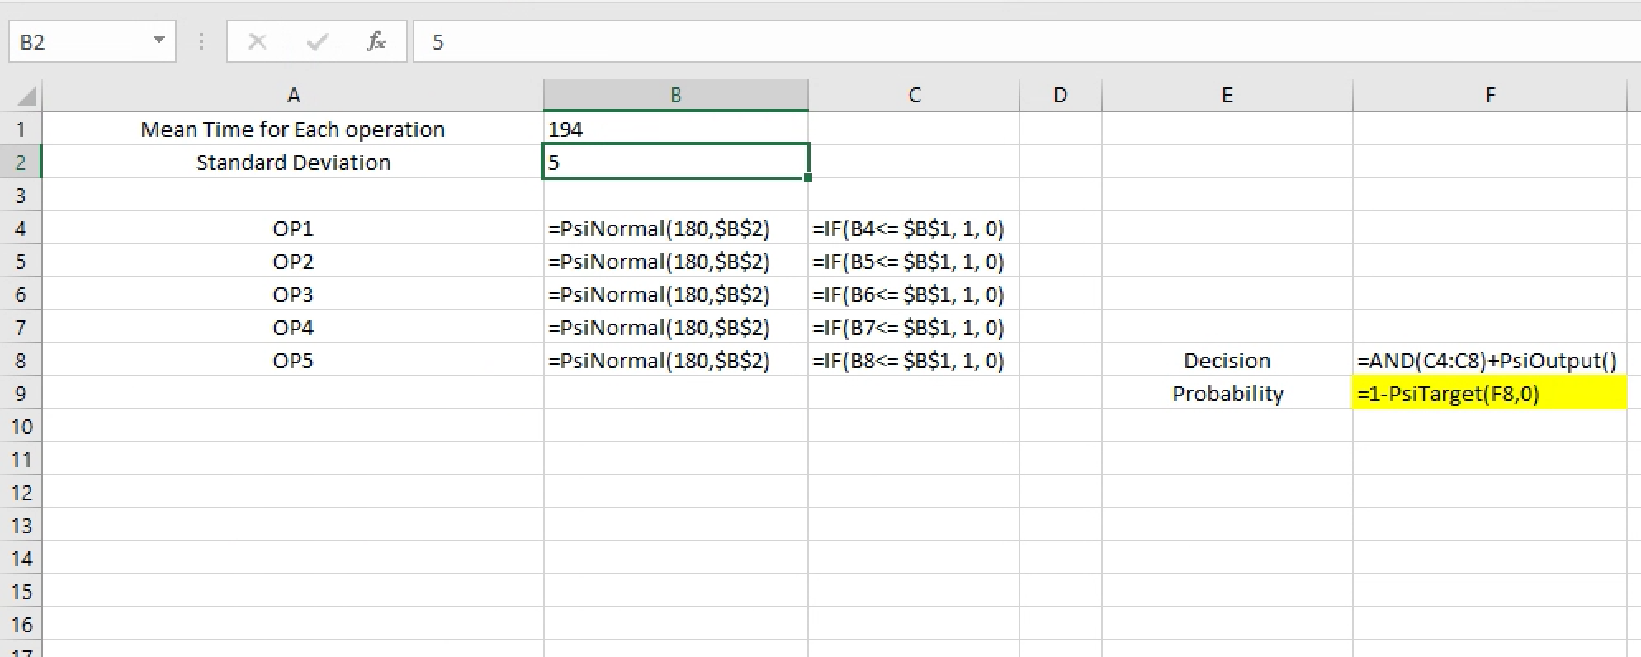

Q3 a)

On average a 65 year old male expects to live **79.544 years**

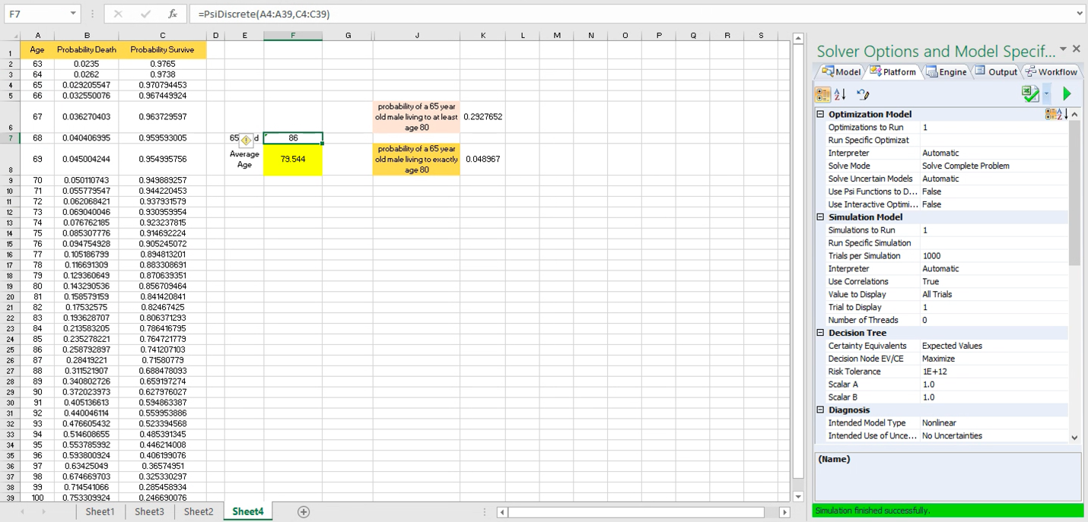

**Plot Distribution**

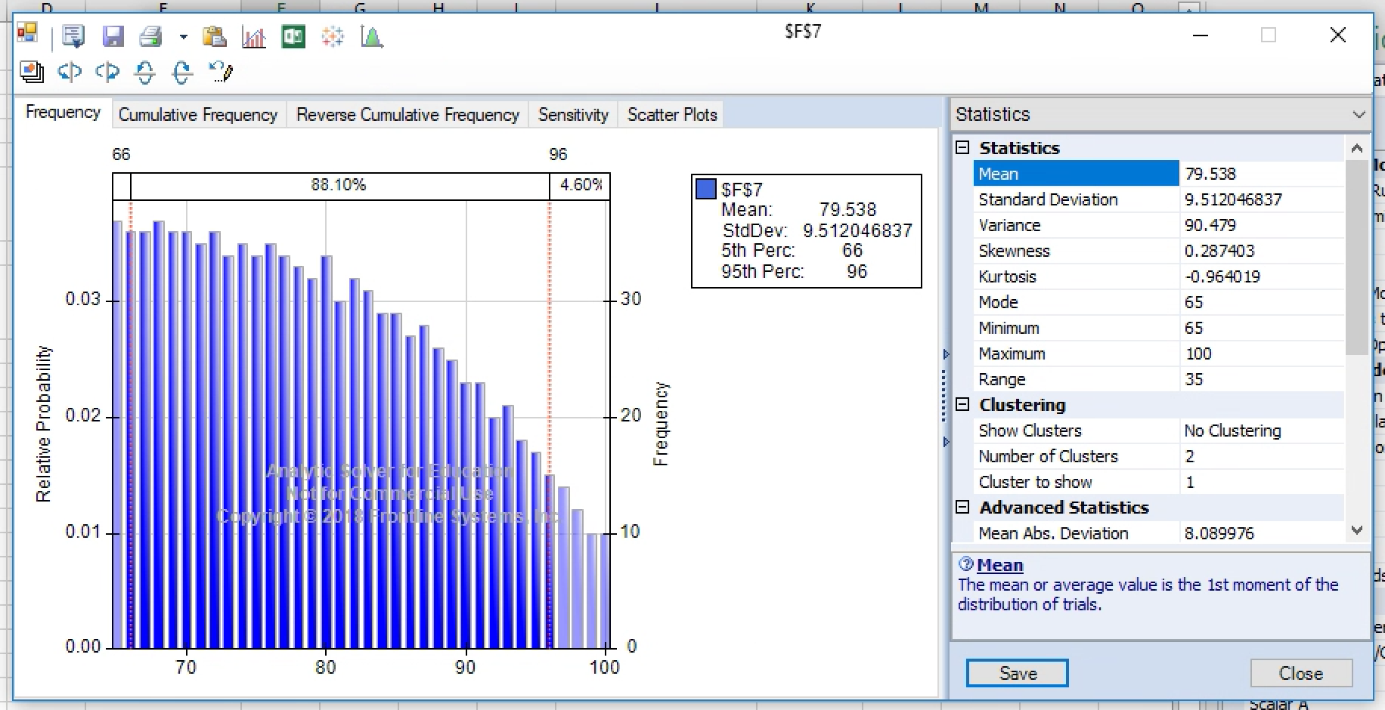

Q3 b)

The probability of a 65 year old male living to at least age 80 is **0.2927**

**Spread Sheet Implementation**

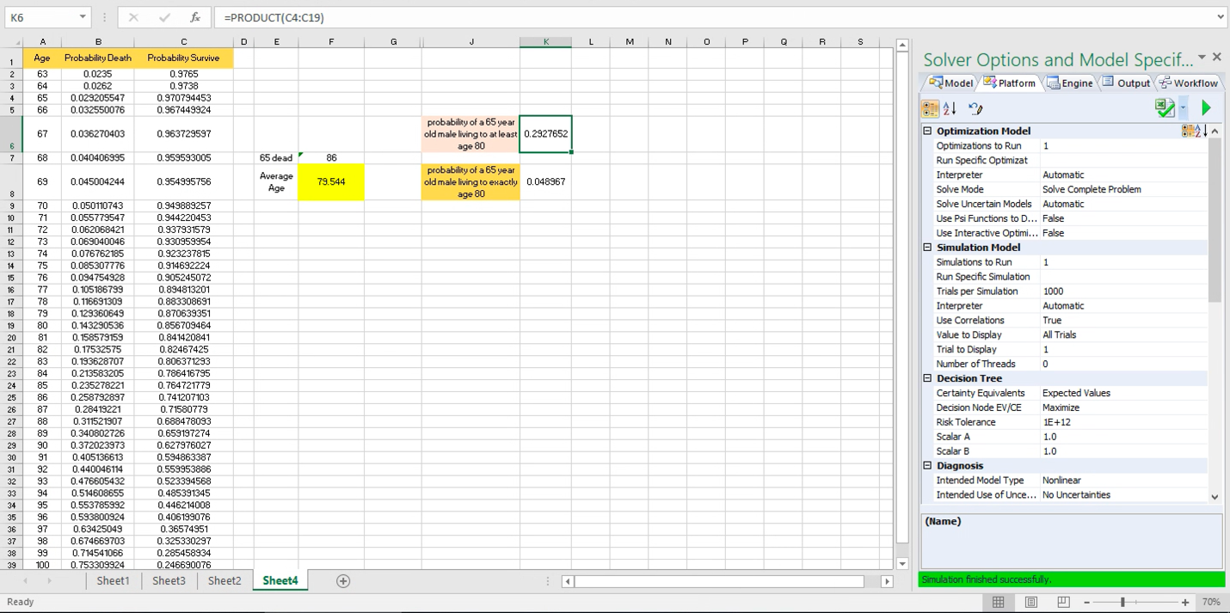

Q3 c)

The probability of a 65 year old male living to exactly age 80 is **0.048967**

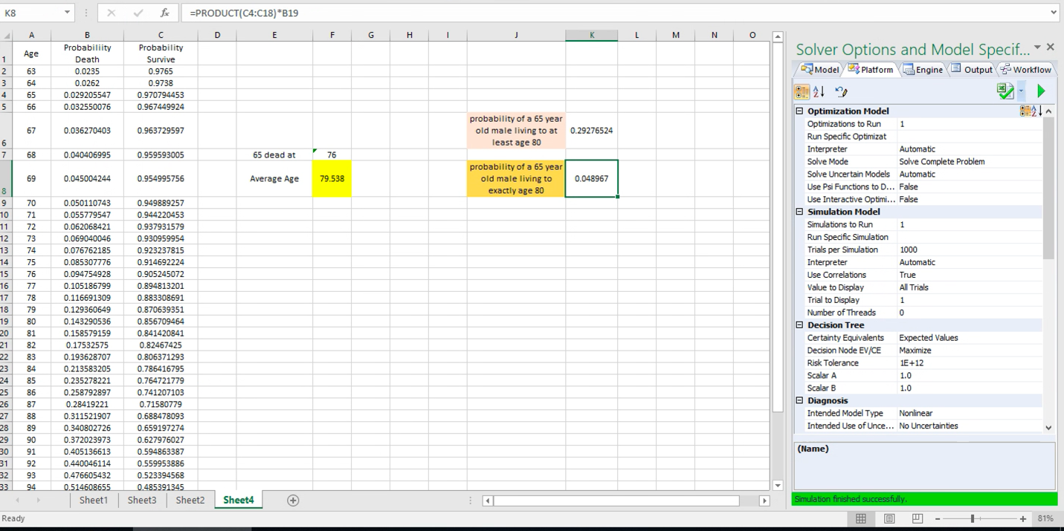

**Formula Sheet**

